**STRINGS**

SARTHAK SANAY

**(1) AIM:-**

To write a program in C to check whether two strings given by the user are anagrams of each other or not.

**CODE :-**

**#include <stdio.h>**

**#include <string.h>**

**int main ()**

**{**

**char str1[100], str2[100];**

**int len1, len2, len, i, j, found= 0, notFound= 0;**

**printf("Enter first string: ");**

**scanf("%s", str1);**

**printf("Enter second string: ");**

**scanf("%s", str2);**

**// finding length of the strings**

**len1= strlen(str1);**

**len2= strlen(str2);**

**// use if statement to check the length is equal or not**

**if(len1 == len2)**

**{**

**len= len1; // assign the length to len variable**

**for(i=0; i<len; i++)**

**{**

**found= 0;**

**for(j=0; j<len; j++)**

**{**

**// checking whether each character of str1 is there in str2 or not, irrespective of positioning**

**if(str1[i] == str2[j])**

**{**

**found= 1;**

**break;**

**}**

**}**

**if(found == 0)**

**{**

**notFound = 1; // assign 1 to notFound**

**break;**

**}**

**}**

**if(notFound == 1)**

**printf("%s and %s are not Anagram.\n\n",str1,str2);**

**else**

**printf("%s and %s are Anagram.\n\n",str1,str2);**

**}**

**else**

**printf("%s and %s are not Anagram as their string size is not same.\n\n",str1,str2);**

**return 0;**

**}**

**OUTPUT SCREEN:-**

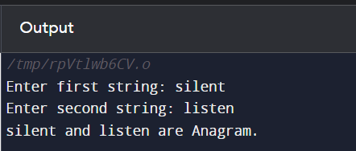

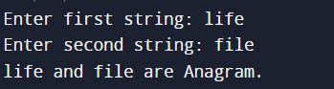

**(2) AIM:-**

To write a program in C to convert a string given by the user to uppercase or lowercase.

**CODE :-**

**// Using built-in functions strupr and strlwr to carry out the operations**

**#include <stdio.h>**

**#include <string.h>**

**int main()**

**{**

**int ch;**

**char s[100];**

**printf("Enter a string: ");**

**gets(s);**

**printf("Enter 1 to convert it into uppercase and 2 to convert it into lowercase: ");**

**scanf("%d", &ch);**

**if(ch==1)**

**printf("Uppercase: \t%s\n", strupr(s));**

**else if(ch==2)**

**printf("Lowercase: \t%s\n", strlwr(s));**

**else**

**printf("Enter correct number as input for choice.");**

**return 0;**

**}**

**OUTPUT SCREEN :-**





**(3) AIM:-**

To write a program in C to remove all occurrences of a specified character from a given string by the user.

**CODE :-**

**#include <stdio.h>**

**#include <string.h>**

**int main()**

**{**

**char str[200], rem;**

**printf("Enter string: ");**

**gets(str);**

**printf("Enter character to remove all its occurences: ");**

**scanf("%c", &rem);**

**int len = strlen(str);**

**for(int i=0; i<len; i++)**

**{**

**// Shifting all characters to one place left and decrementing the length of string by 1, if the character is found.**

**if(str[i] == rem)**

**{**

**for(int j=i; j<len; j++)**

**{**

**str[j] = str[j+1];**

**}**

**len--;**

**i--; // not incrementing i when a character is found, as we are decreasing the size of string by 1**

**}**

**}**

**printf("String after removing '%c': %s", rem, str);**

**return 0;**

**}**

**OUTPUT SCREEN :-**

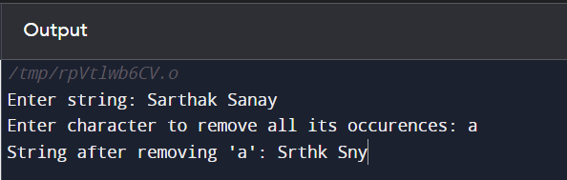

**P.T.O.**

**(4) AIM:-**

To write programs to perform string manipulation (concatenation, copying).

**CODE 1 :- (Concatenation)**

**// Program in C to demonstrate string manipulation (Concatenation)**

**// Using strcat, a built-in function in C to concatenate (join) a string A with another string B**

**#include <stdio.h>**

**#include <string.h>**

**int main()**

**{**

**char A[100], B[100];**

**printf("Enter String A: ");**

**scanf("%s", A);**

**printf("Enter String B: ");**

**scanf("%s", B);**

**// Concatenating String A with B (it will be stored in the variable passed first in the paranthesis)**

**strcat(A, B); // Understand it as A= A + B**

**printf("Concatenated String is:- %s", A);**

**return 0;**

**}**

**OUTPUT SCREEN 1 :-**

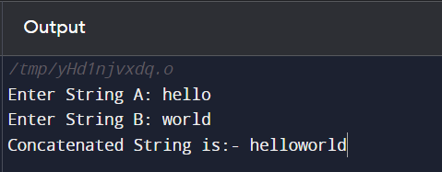

**CODE 2 :- (Copying)**

**// Program in C to demonstrate string manipulation (Copying)**

**// Using strcpy, a built-in function in C to copy a string from one variable to another**

**#include <stdio.h>**

**#include <string.h>**

**int main()**

**{**

**char A[100], B[100];**

**printf("Enter string to be stored in A which will be copied in B as well:- \n");**

**gets(A);**

**// Copying string from variable A to B**

**strcpy(B, A); // Syntax:- strcpy(destination, source)**

**printf("String A:- %s", A);**

**printf("\nString B:- %s", B);**

**return 0;**

**}**

**OUTPUT SCREEN 2:-**

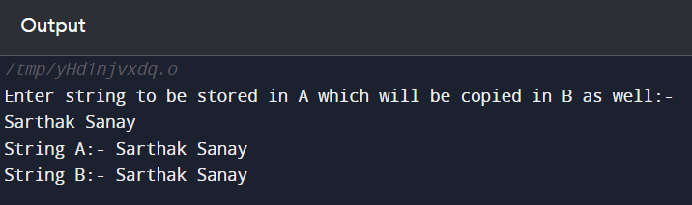

**(5) AIM:-**

To write a program in C to count the number of vowels and consonants in a given string by the user.

**CODE:-**

**#include <stdio.h>**

**#include <string.h>**

**int main()**

**{**

**char str[100];**

**int vowCount=0, consCount=0;**

**printf("Enter string: ");**

**scanf("%s", str);**

**int len= strlen(str);**

**for(int i=0; i<len; i++)**

**{**

**if(str[i]=='a' || str[i]=='A' || str[i]=='e' || str[i]=='E'**

**|| str[i]=='i' || str[i]=='I' || str[i]=='o' || str[i]=='O'**

**|| str[i]=='u' || str[i]=='U')**

**vowCount++;**

**else**

**consCount++;**

**}**

**printf("Number of Vowels: %d\n",vowCount);**

**printf("Number of Consonants: %d",consCount);**

**return 0;**

**}**

**OUTPUT SCREEN:-**

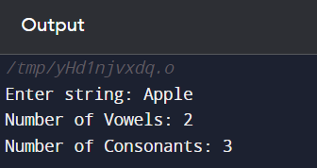

**(6) AIM:-**

To write a program in C to reverse a string given by the user.

**CODE:-**

**#include <stdio.h>**

**#include <string.h>**

**int main()**

**{**

**char str[100];**

**printf("Enter string: ");**

**gets(str);**

**int len= strlen(str);**

**char rev[len];**

**int i, j=0;**

**for(int i=len-1; i>=0; i--)**

**{**

**rev[j]= str[i];**

**j++;**

**}**

**printf("Reverse of %s is: %s", str, rev);**

**return 0;**

**}**

**OUTPUT SCREEN:-**

